PRACTICAL - 1

Aim : Identify any open source software and create detail report about it.

OPEN SOURCE SOFTWARE : FileZilla

1. Idea :

* The main purpose/idea to invert this open source software was that it allows users to set up FTP servers or connect to others FTP servers in order to exchange files.
* FileZilla was started as a computer science class project in the second week of January 2001 by Tim Kosse and two classmate.

1. What problem does it solved ?

* It helps to transfer files from a local computer to a remote one.
* It also supports secure file transfer protocol, i.e. SFTP, and is available as in both client and server versions

1. Licensing model :

* FileZilla is distributed under the Terms and Conditions of the GNU General Public License (GPL) version 2 or any later version.
* FileZilla is distributed under the Terms and Conditions of the GNU Affero General Public License (AGPL) version 3 or any later version.

1. Intent behind making it open source :

* They decided to make FileZilla an open source project because many FTP clients were already available, and they didn’t think that they would se a single copy if they make FileZilla commercial.

1. Monetization model :

* Support and services works well as a business model for infrastructure software, enterprise software, and things like storage.
* It works a lot less well for software marketed to developers, or personal end_user software.
* In both of those cases, your user base is more likely to do without that to pay.

1. Popularity :

* The two top countries that use FileZilla for FTP File uploads are United States with 1323 (62.20%) and India with 249 (11.31%) customers.
* The average countries that use FileZilla for FTP and File uploads are United Kingdom with 195 (9.19%) followed by Canada with 121 (5.74%) and France with 110 (5.19%) customers.
* Italy with 80 (3.4%) and Spain with 68 (2.85%) are the two least countries which use FileZilla.

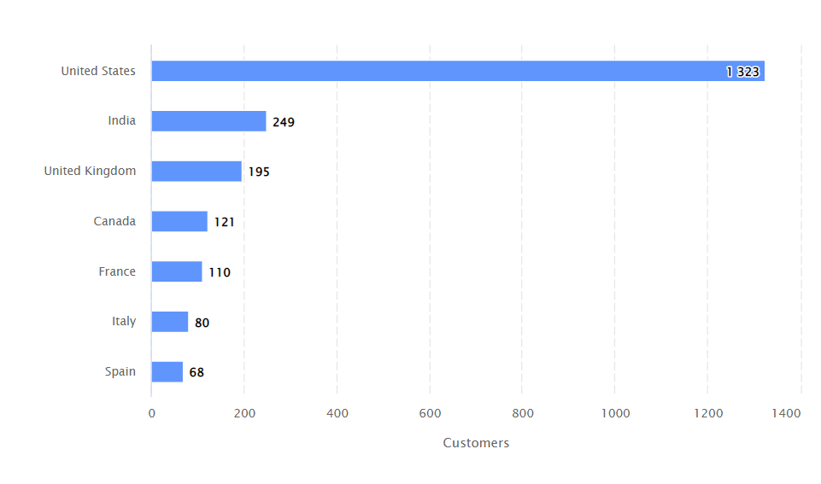

1. Impact :

* It made easy to use graphical user interface to configure and manage file transfer operations.
* It supports clients from almost all platforms – Windows, Mac OS, Linux, making it one of the comprehensive FTP server application.